- Dataset 1 # id:11--22-11-1
  - 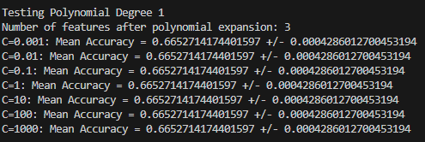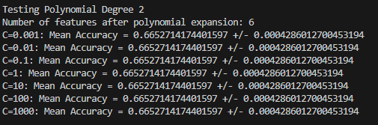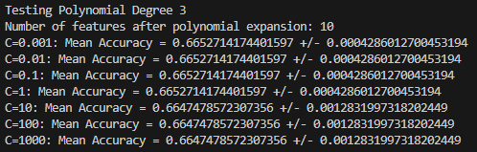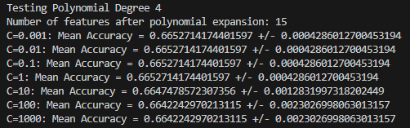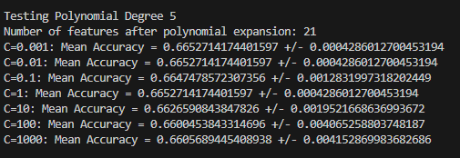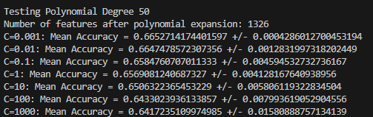
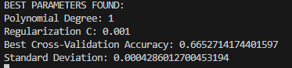
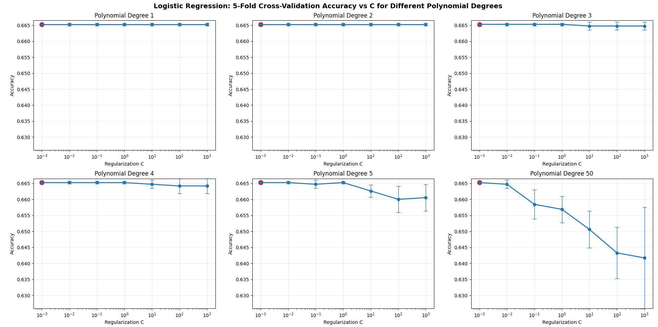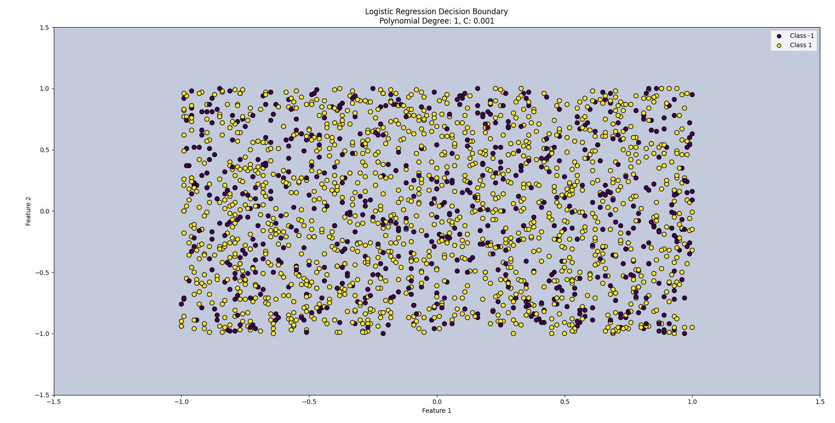
This model didn’t work well, the best classifier found was the first, as they all have equal or worse performance. Looking at the data we can tell that no possible decision boundary could do any better than a “most frequent” classifier
  - 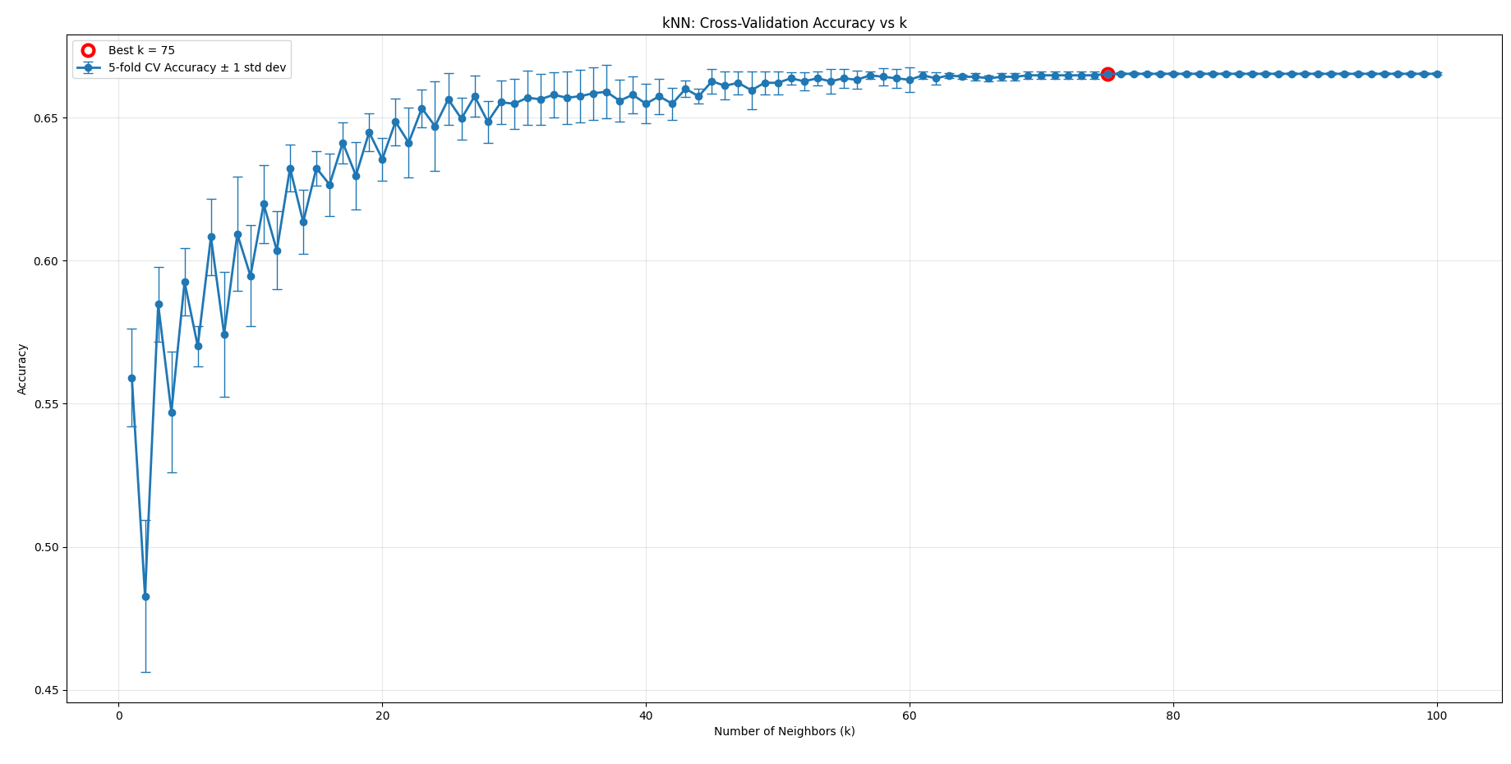
The kNN classifier was again evaluated with 100 values for k, while the performance did improve for a while it plateaud at k=75
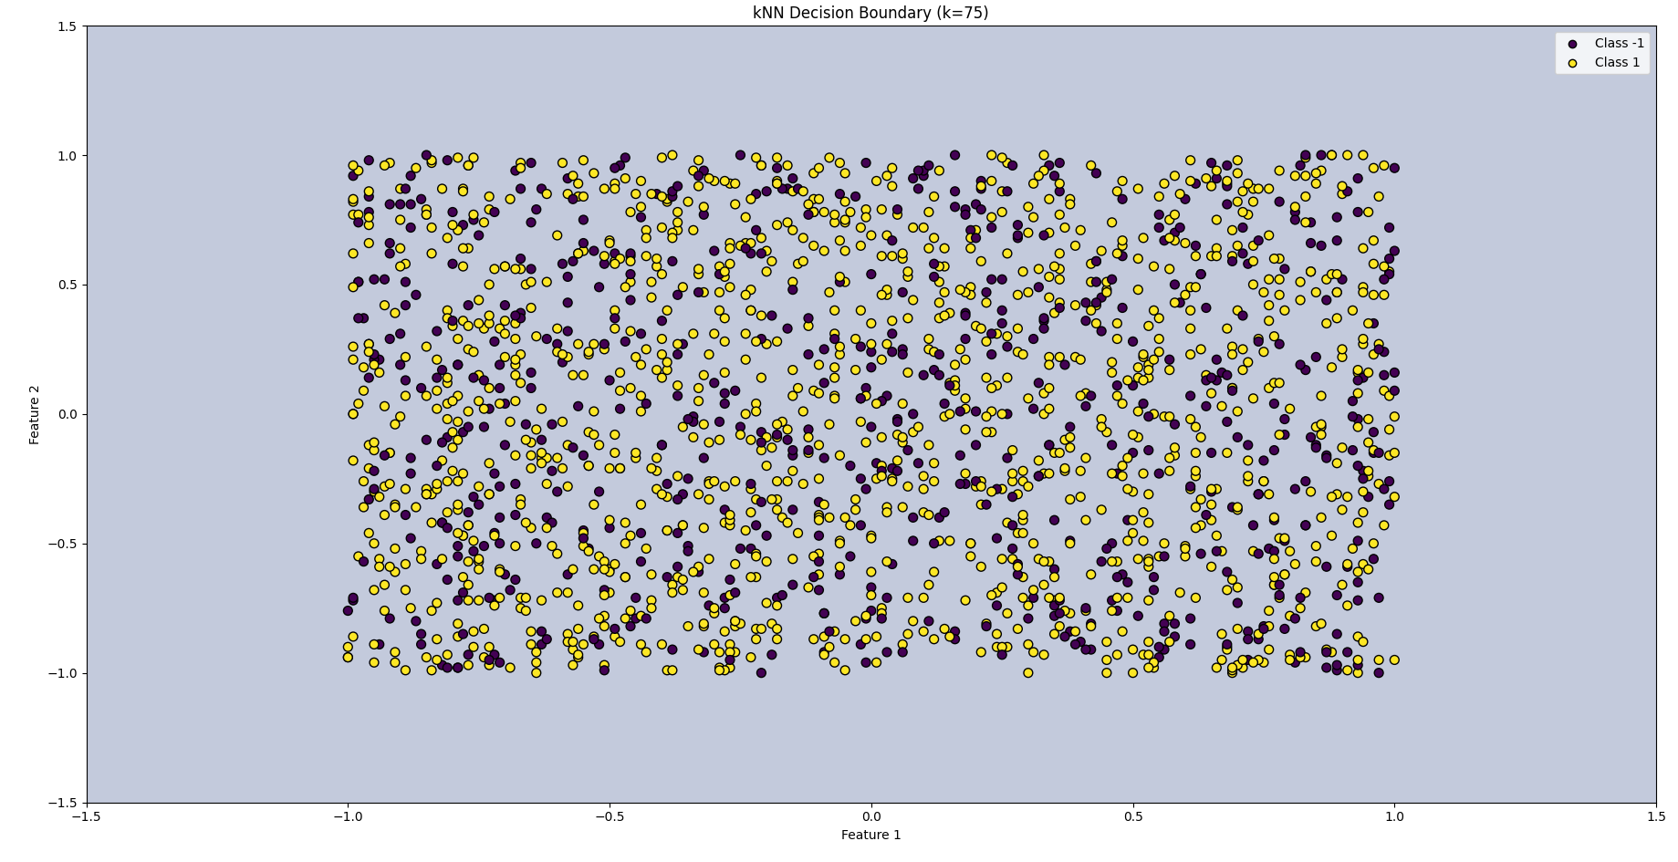
We can again see that no possible decision boundary could resolve this

The accuracy and standard deviation of the model being identical to the logistic regression model proves that both models have moved their decision boundary far from the table
  - 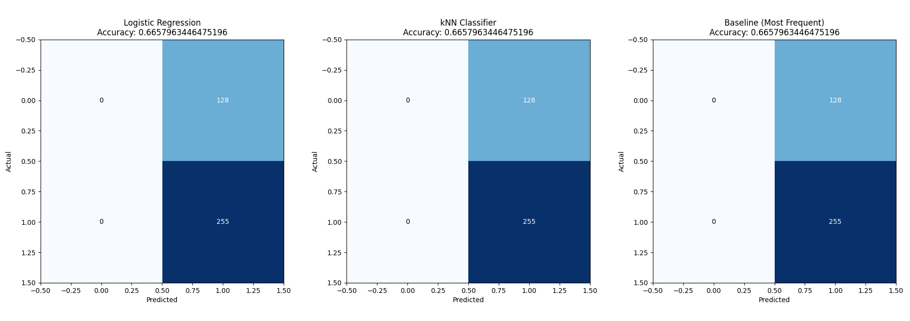
Here we can see that all 3 classifiers return identical results, with each of them predicting that all entries will be positive, allowing them to correctly guess 255/383 points
  - 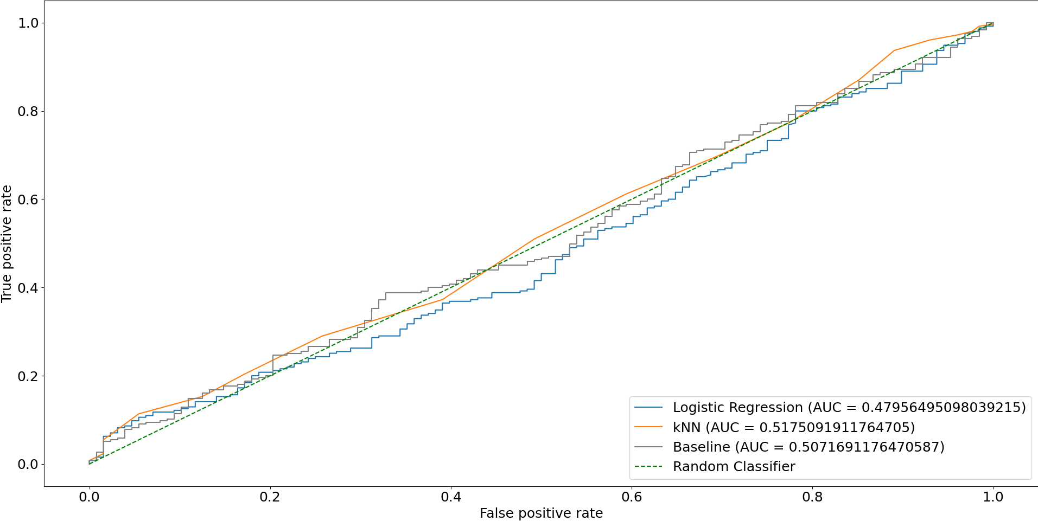
Again all 3 models return very similar performance on the ROC curves
While the logistic regression slightly underperformed, the kNN and baseline slightly overperformed the random classifier, but this is subject to chance, as these models are so close to the line that their random guessing seems vary their curve enough to sway the score either way.
I don’t believe that the slight difference in performance here is indicative of anything.
  - Altogether I would recommend the “most frequent” classifier, as all the models perform so similarly, but the most frequent classifier is the easiest to implement and has the highest efficiency.

- Dataset 2 # id:11--22-11-1
  - 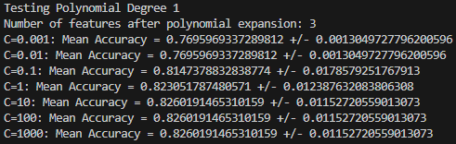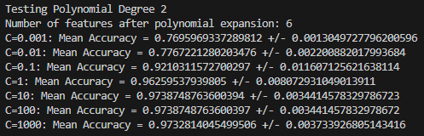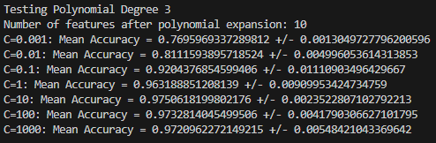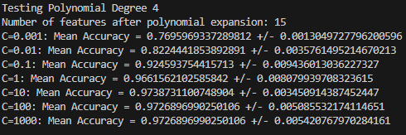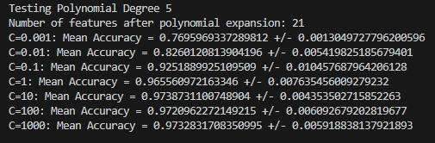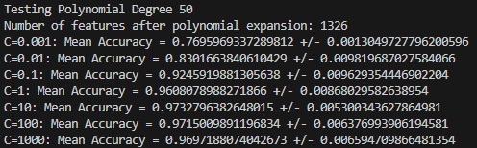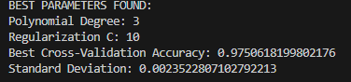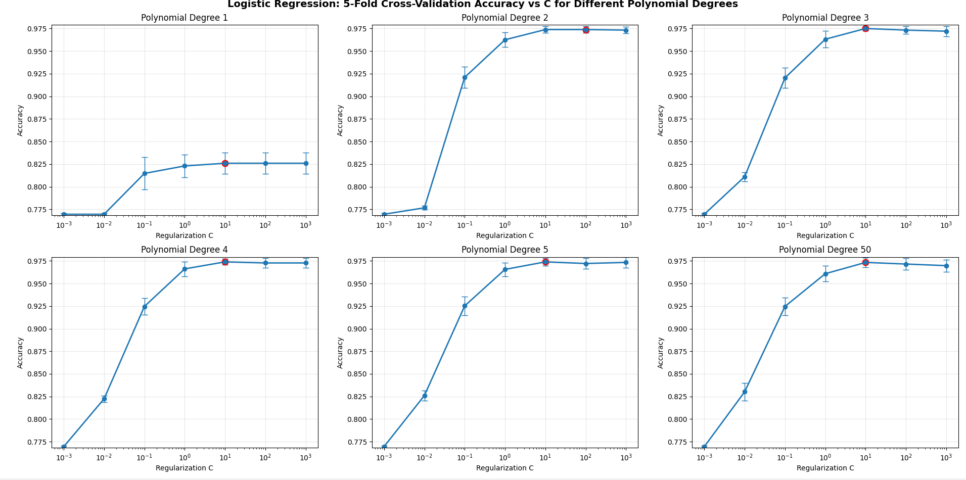
By creating a model for each combination of polynomial degree and C-value I was able to create 42 separate models, of which the polynomial degree of 3 with C value of 10 created the best model, with an accuracy of 0.975 and a standard deviation of 0.00235.
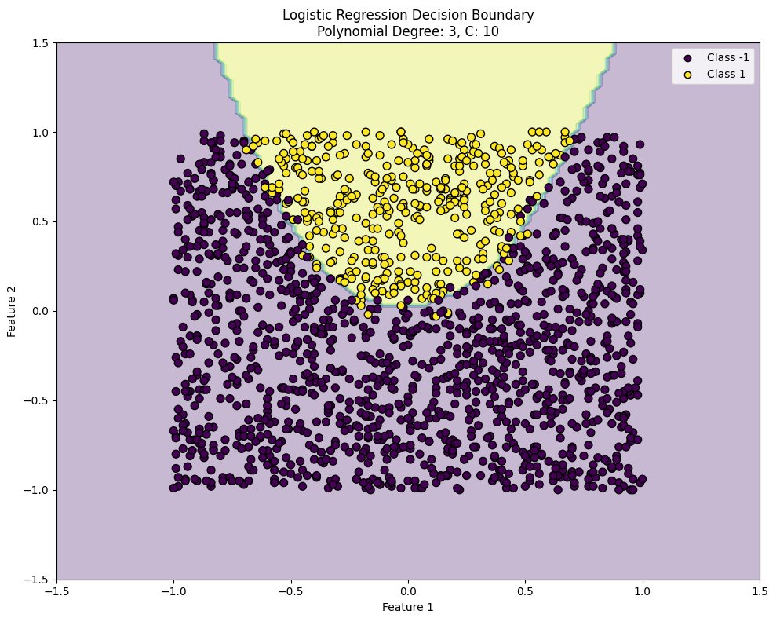
We can see that the decision boundary seems well suited with no signs of overfitting
  - 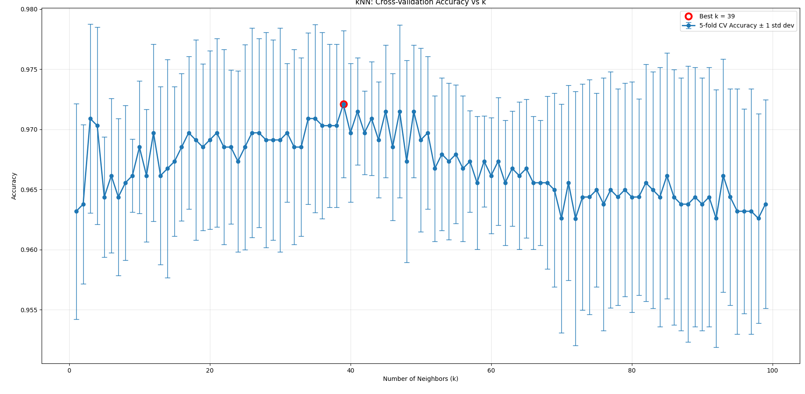
The kNN classifier was evaluated with k values from 1 to 100, we can see from the graph that the best performing k-value was 39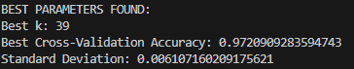With an accuracy of 0.972 and a standard deviation of 0.0061.
This model slightly underperforms compared to the the logistic regression model.
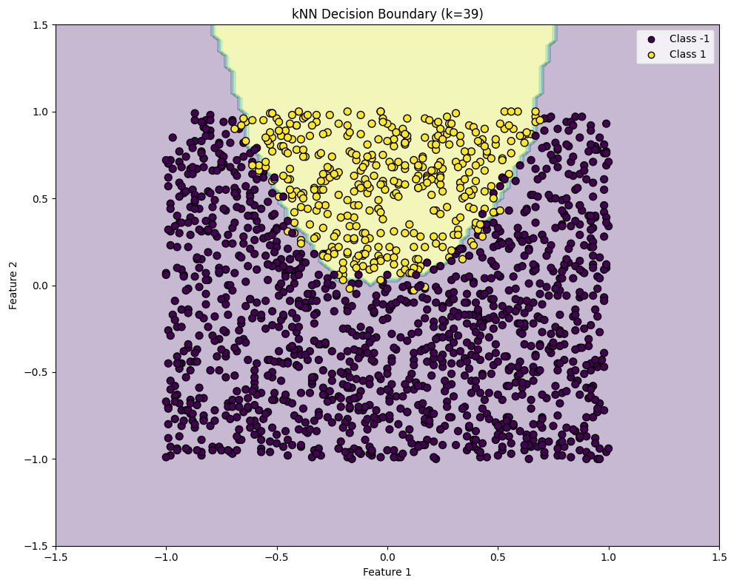
The decision boundary again seems very well suited with no signs of overfitting
  - 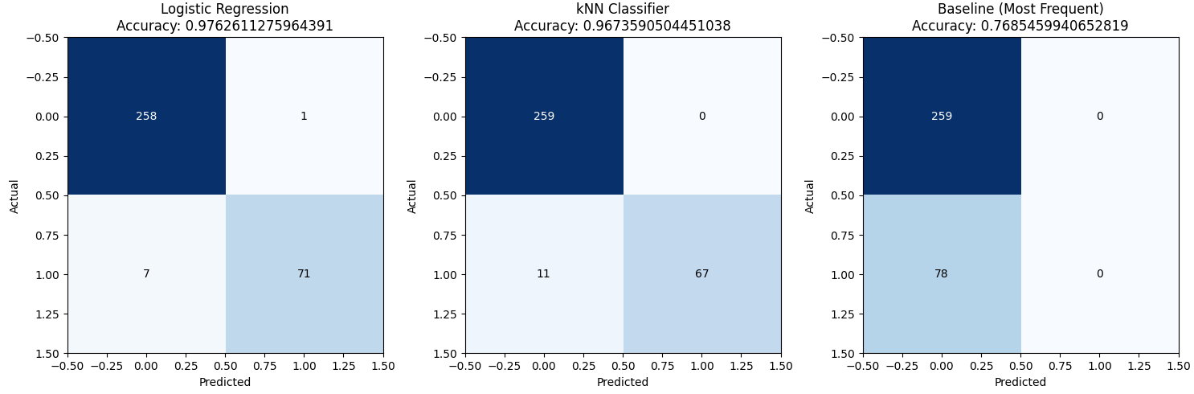
The 2 models were compared against each other and a baseline(most frequest) model.
I used a 20% test split from full data set.
Logistic regression can be seen outperforming KNn again, we can see that both models significantly outperform the baseline model, making 8/11 mistakes as opposed to 78
  - 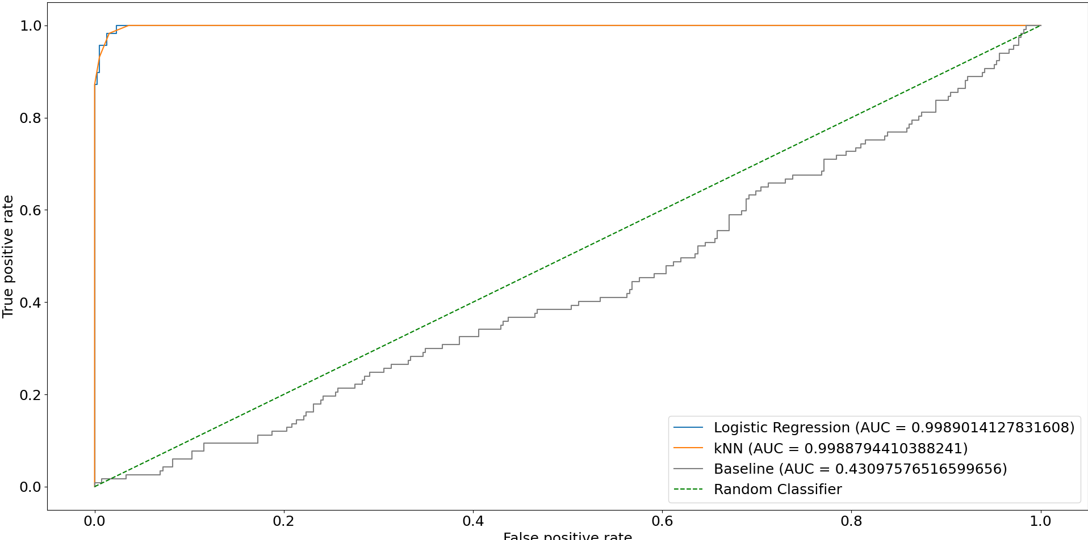
The Logistic rRegression and the kNN plot performed incredibly well with an AUC of 0.9989
The baseline classifier performed horribly with an AUC of 0.43
  - Altogether I would recommend the Logistic regression model as it has slightly higher accuracy and more understandable weights.

